Experiment No. 6
Case Study: Predicting Salary based on Experience using Simple Linear Regression

1. Aim
To implement Simple Linear Regression to predict employee salary based on years of experience.

2. Objectives
• To understand the concept of regression analysis
• To build a linear regression model for prediction
• To visualize the relationship between experience and salary
• To evaluate the model using MSE, MAE, RMSE, and R² score
3. Software Required
• Python 3.x
• Jupyter Notebook / Google Colab
• Pandas
• Matplotlib
• Scikit-learn

4. Introduction
Regression is a supervised learning technique used to predict continuous values. Simple Linear Regression establishes a linear relationship between:
• Independent variable (X): Years of Experience
• Dependent variable (Y): Salary
The model predicts salary using a straight-line equation.

5. Mathematical Model
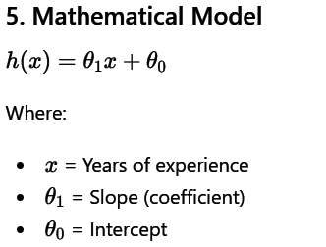

6. Dataset Description
The dataset contains salary information based on employee experience. Feature Description
YearsExperience Number of years of experience
Salary Annual salary
7. Steps / Algorithm
1. Import libraries
2. Load dataset
3. Split dataset into training and testing sets
4. Train the model using Linear Regression
5. Predict salary values
6. Visualize results
7. Evaluate model performance
8. Program
# Import libraries
import pandas as pd
import matplotlib.pyplot as plt
from sklearn.model_selection import train_test_split
from sklearn.linear_model import LinearRegression
from sklearn import metrics
import numpy as np

# Load dataset
data = pd.read_csv('Salary_Data.csv')

# Independent and dependent variables
X = data[['YearsExperience']]
y = data['Salary']

# Split dataset
X_train, X_test, y_train, y_test = train_test_split(X, y, test_size=0.2, random_state=0)

# Train model
model = LinearRegression()
model.fit(X_train, y_train)

# Predict
y_pred = model.predict(X_test)

# Visualization
plt.scatter(X, y, color='red')
plt.plot(X, model.predict(X), color='blue')
plt.xlabel('Years of Experience')
plt.ylabel('Salary')
plt.title('Salary vs Experience')
plt.show()

# Evaluation
mse = metrics.mean_squared_error(y_test, y_pred)
mae = metrics.mean_absolute_error(y_test, y_pred)
rmse = np.sqrt(mse)
r2 = metrics.r2_score(y_test, y_pred)

print("MSE:", mse)
print("MAE:", mae)
print("RMSE:", rmse)
print("R2 Score:", r2)

9. Output
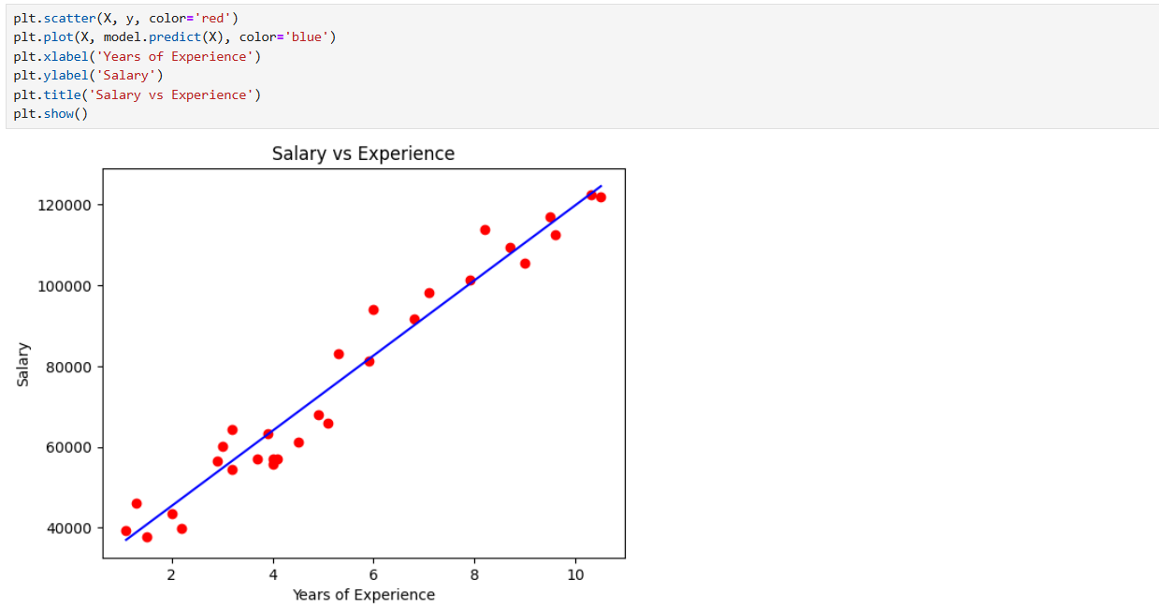
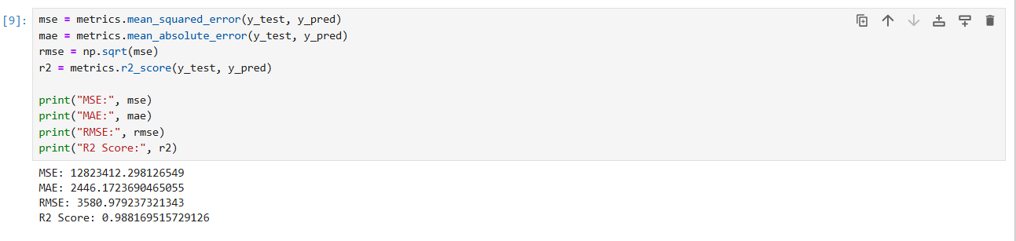
10. Graph Interpretation
• Red dots represent actual data points
• Blue line represents regression line
• The line shows positive linear relationship between experience and salary 11.
Result:
The model successfully predicted salary based on experience with high accuracy.
12. Conclusion
Simple Linear Regression is effective for predicting continuous values when a linear relationship exists between variables. The model performed well with a high R² score, indicating a strong fit.

13. Viva Questions & Answers

1. What is regression?
Regression is a technique used to predict continuous values based on input data.

2. What is Simple Linear Regression?
It is a method to model the relationship between one independent and one dependent variable.

3. What is the equation of a line?
y=mx+c

4. What are dependent and independent variables?
Independent (X): Input variable
Dependent (Y): Output variable

5. What is the role of slope and intercept?
Slope: Rate of change
Intercept: Value when X = 0

6. What is overfitting?
When a model learns training data too well and performs poorly on new data.

7. What is R² score?
It measures how well the model fits the data (range 0 to 1).

8. What is MAE?
Mean Absolute Error — average of absolute differences between actual and predicted values.

9. What is RMSE?
Root Mean Square Error — square root of MSE, penalizes large errors.

10. Why do we split data into training and testing sets?
To evaluate model performance on unseen data.

